1. Configuration Paramètres :

Screen Layout :



< CONFIG>



1. Communication params :

|  |  |  |  |
| --- | --- | --- | --- |
| Fields | Len | Type | Comment |
| Type | 1 | Char | Server Type :  C : Client  S : Server |
| Header Comm | 1 | Char | Comm with Header Y/N |
| Header Comm Len | 2 | Int | Header Length 2, 4 |
| Header Type | 1 | Char | Ascii / Binaire |
| IP | 16 | Char | Server IP Adresse |
| Port | 5 | Int | Server PORT |
| Mac Management | 1 | Char | Mac Management Y/N |
| Message Header | 1 | Char | Message with Header Y/N |
| Message Header | 64 | Char | Message Header |

1. Acquirer Institutions:

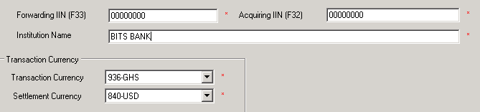

1. Issuer Institutions:

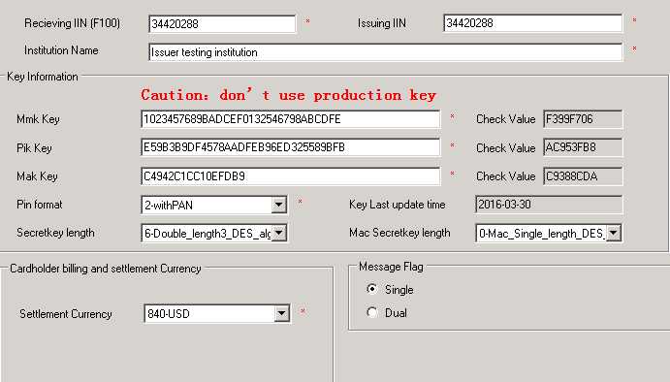

1. Other Parameter:

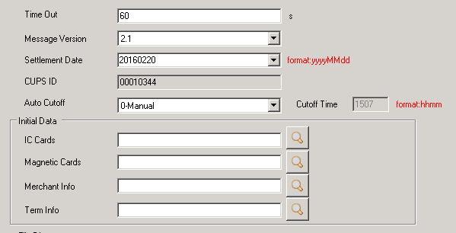

1. Management
   1. Country Parameters

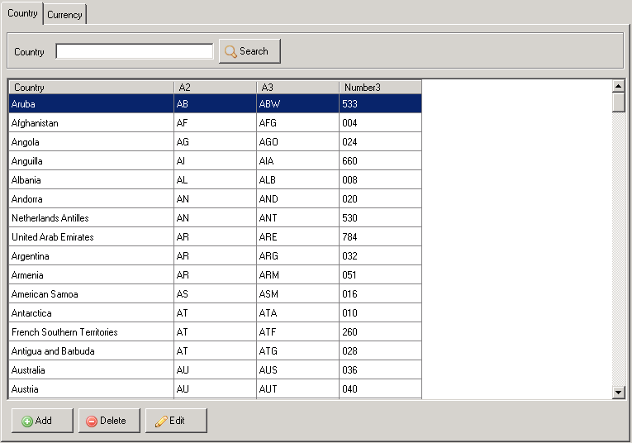

* 1. Currency Parameters

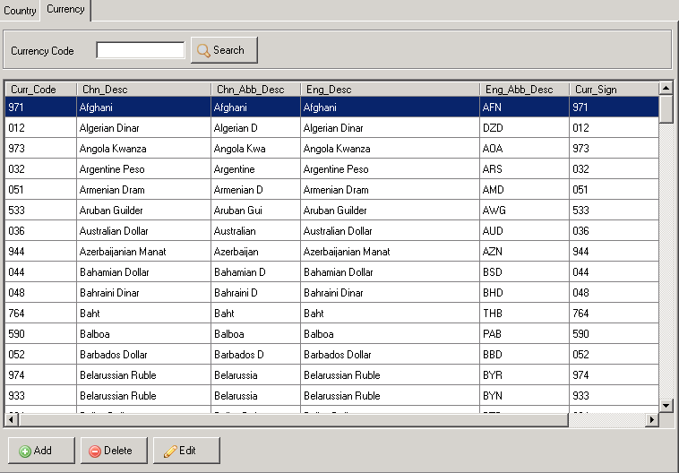

* 1. Exchange Rate

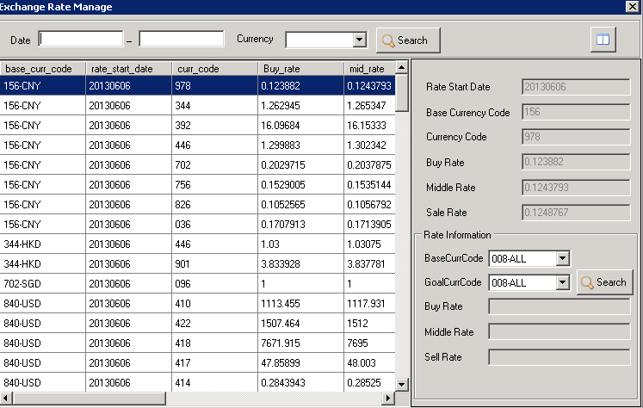

* 1. Fee configuration.

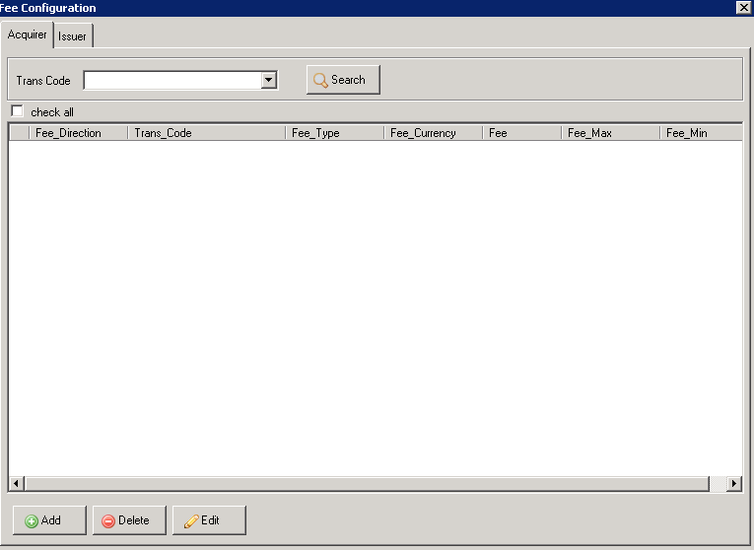

* 1. Merchant and terminal Management

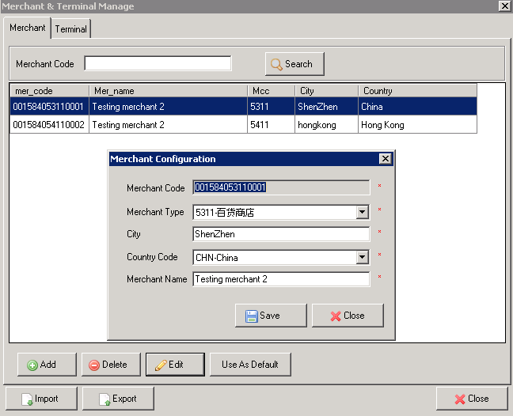

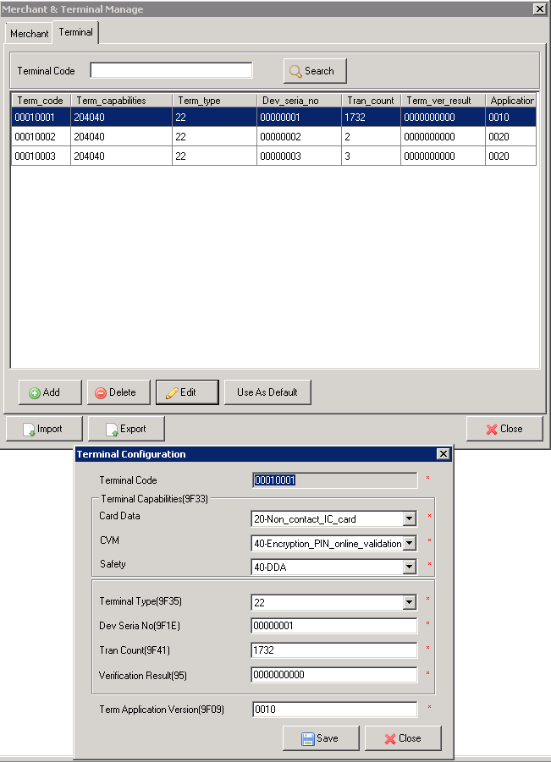

* 1. Card Configuration
     1. General

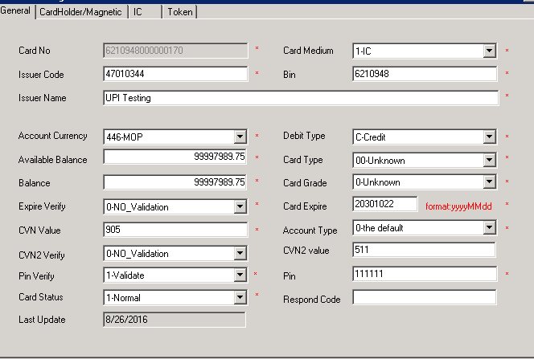

* + 1. Magnetic

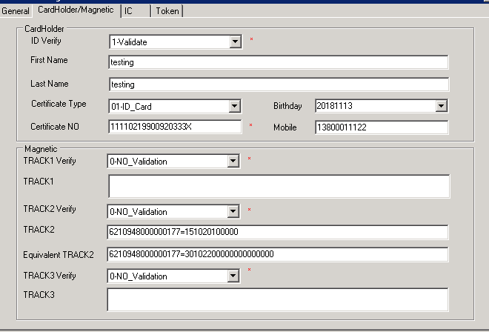

* + 1. IC

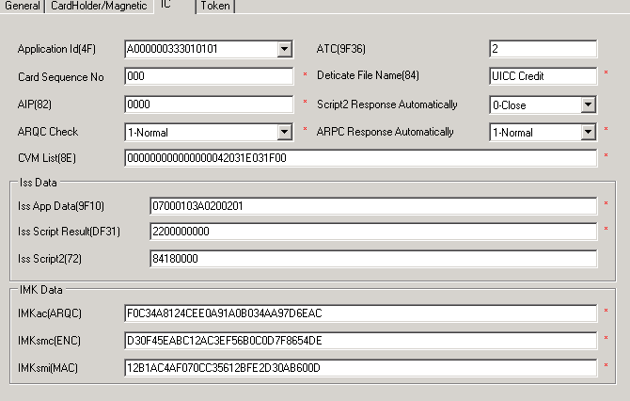

* 1. Case Management

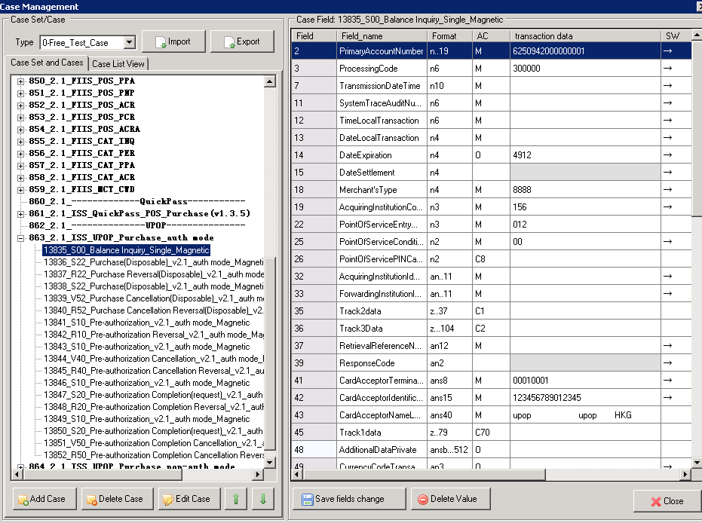

* 1. Added case

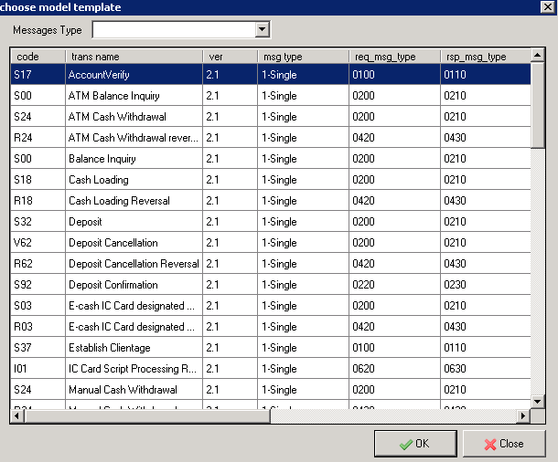

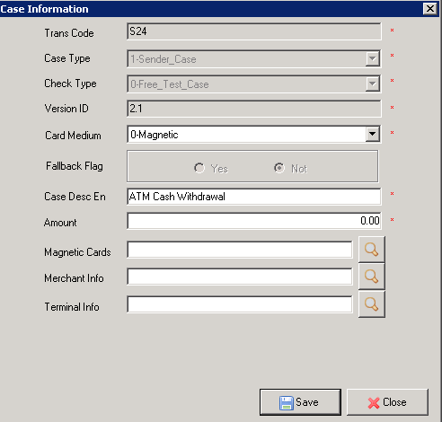

1. Testing Excution :

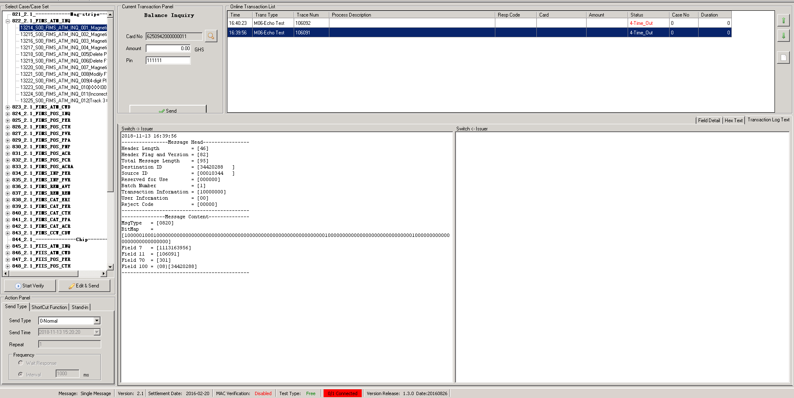

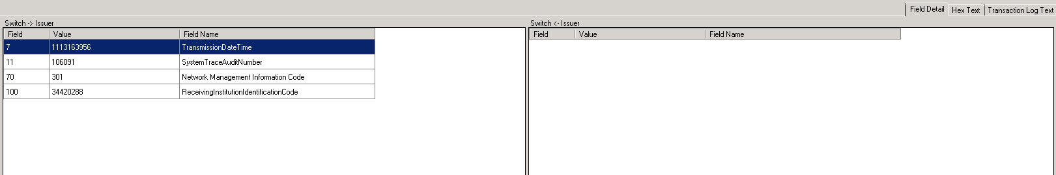

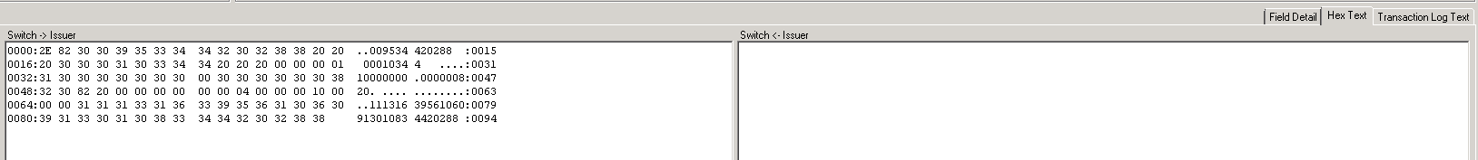

1. Transaction Result :

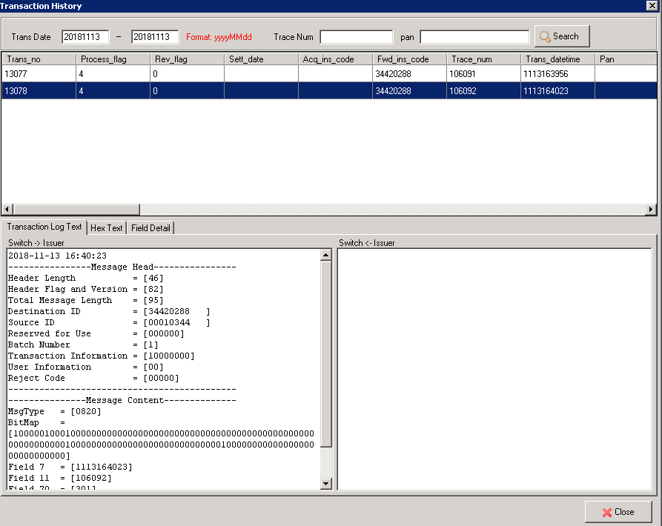

1. Error Log

